Site photos taken out of report:

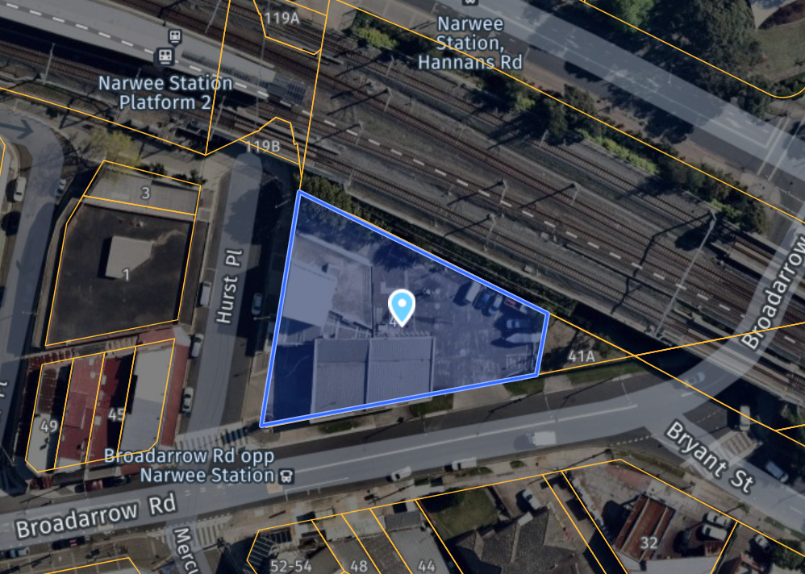

**Figure 1:** Aerial Map of the subject site outlined in blue (Source: NearMap 2020)

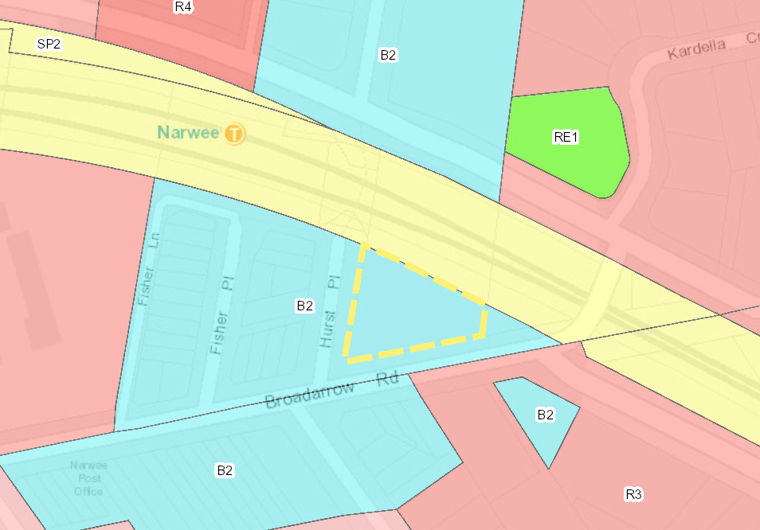

**Figure 2:** Zoning Map showing site outlined in yellow (**Source:** NSW Planning Portal 2020)

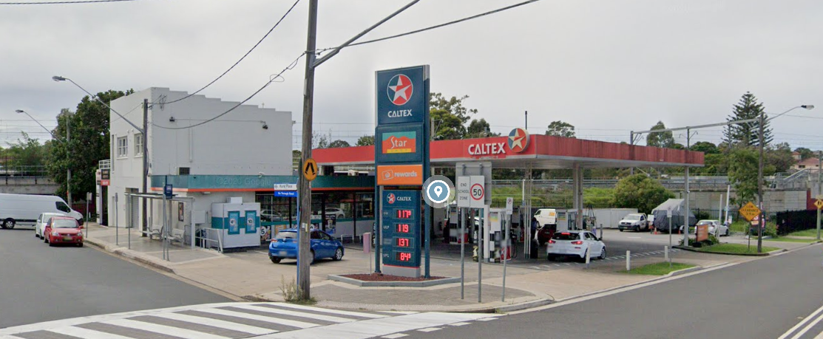

**Figure 3:** View of the subject site from the intersection of Broadarrow Road and Hurst Place (**Source:** Google Maps).

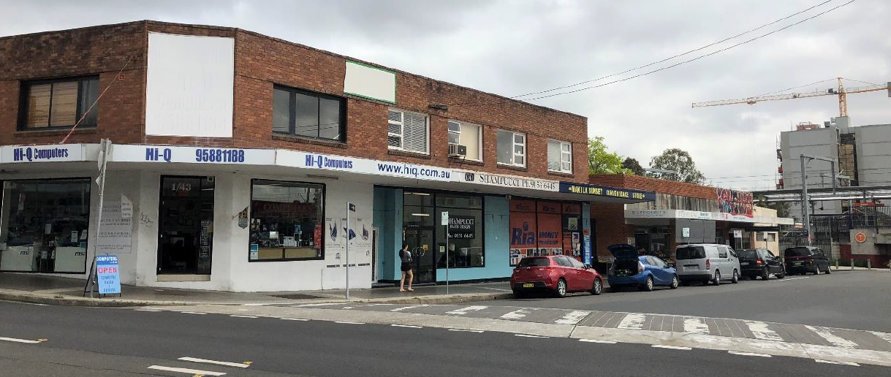

**Figure 4:** View of the surrounding locality in Hurst place, to the west of the site (**Source:** Google Maps).